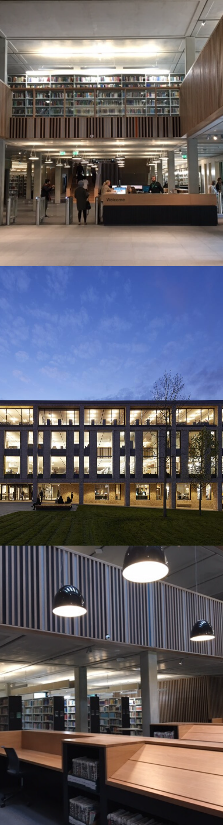

Library Opening Hours

Monday - Friday 8am - Midnight

Saturday - Sunday 10am - 9pm

